from threading import Thread

from queue import Queue

import time

def sender_thread(msg_queue,messages):

  for m in messages:

    print(f"Sender = {m} is sending")

    msg_queue.put(m)

    time.sleep(2)

  msg_queue.put(None)

def receiver_thread(msg_queue):

  while True:

    message = msg_queue.get()

    if message is None:

      break

    print(f"Receiver = {message} is receiving")

def main():

  queue_obj = Queue()

  messages = ["Hello","How Are You?","Whats Up"]

  sender = Thread(target=sender_thread,args=(queue_obj,messages))

  receiver = Thread(target=receiver_thread,args=(queue_obj,))

  sender.start()

  receiver.start()

  sender.join()

  receiver.join()

if __name__ == "__main__":

    main()

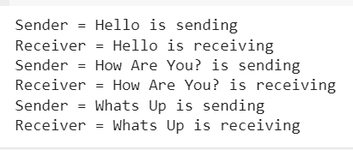

from threading import Thread,Lock

from queue import Queue

import time

import random

class Restaurant:

  def __init__(self):

    self.orders_to_prepare = Queue()

    self.kitchen_lock = Lock()

    self.kitchen_prepared_orders = []

  def place_order(self,order):

    self.orders_to_prepare.put(order)

    print(f"{order} is placed")

  def prepare_order(self):

    while True:

      time.sleep(random.uniform(1,4))

      with self.kitchen_lock:

        if not self.orders_to_prepare.empty():

          result = self.orders_to_prepare.get()

          print(f"Chef is preparing {result}")

          self.kitchen_prepared_orders.append(result)

        else:

          break;

  def serve_order(self):

    while True:

      time.sleep(random.uniform(1,3))

      with self.kitchen_lock:

        if self.kitchen_prepared_orders:

          result = self.kitchen_prepared_orders.pop(0)

          print(f"Waiter is serving {result}")

        else:

          if not self.orders_to_prepare:

            break;

def main():

  rest_obj = Restaurant()

  chef_threads = [Thread(target=rest_obj.prepare_order) for _ in range(3)]

  waiter_threads = [Thread(target=rest_obj.serve_order) for _ in range(3)]

  for chef_thread in chef_threads:

    chef_thread.start()

  for waiter_thread in waiter_threads:

    waiter_thread.start()

  for i in range(5):

    rest_obj.place_order(f"Order : {i+1}")

  for chef_thread in chef_threads:

    chef_thread.join()

  for waiter_thread in waiter_threads:

    waiter_thread.join()

if __name__ == "__main__":

    main()

